CS 385 – Progress Report I

Rachael Grabowski: Diagrams, progress report

Michael Lang: Code

# I. Diagrams

## Single Cycle Simplified Datapath for R-type

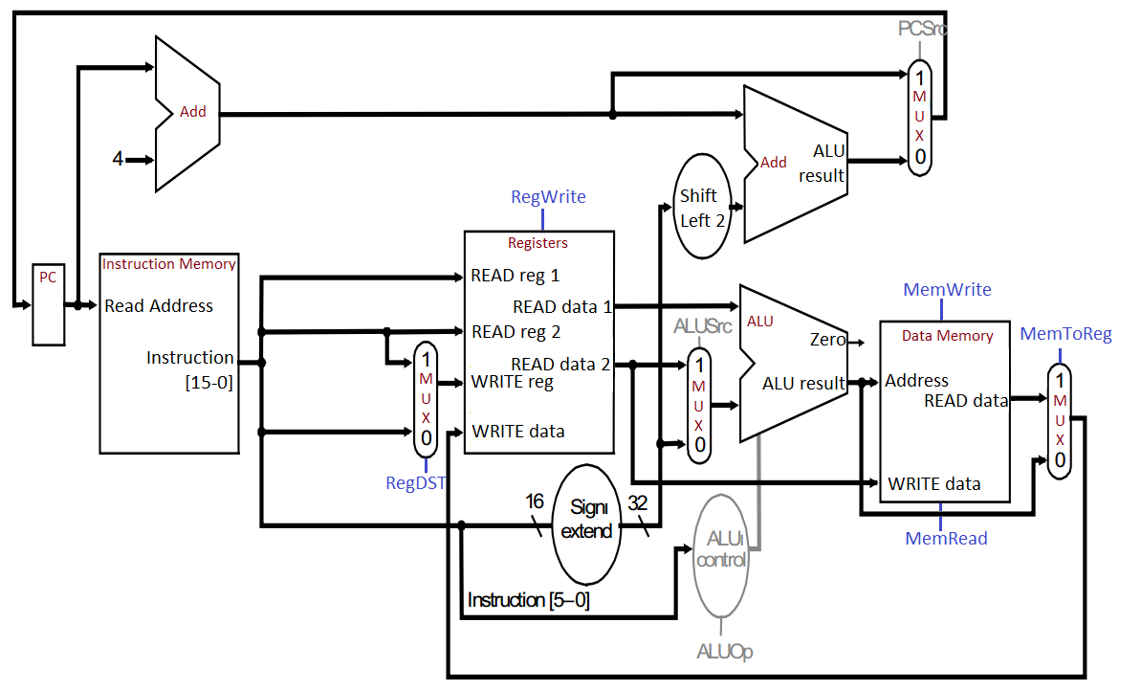

# II. Verilog Source Code

# II. Test Results